CONTACT MANAGER
(React Application)







GOVERNMENT ARTS AND SCIENCE COLLEGE
WIMCO NAGAR
THIRUVOTTIYUR ,CHENNAI-19
CONTACT MANAGER

Team ID: SWTID-2026-7713
Team Size: 4


Team Leader: VIGNESHWARI M
Team Member: DHARANYA A
Team Member: HEMA J
Team Member: YUVAKARTHIKA R

INDEX

- PROJECT TITLE
- PROJECT OVERVIEW
- INSTRUCTION
- TECHNICAL ARCHITECTURE
- FEATURES
- ROLES AND RESPONSIBILITY
- PROJECT SETUP AND CONFIGURATION
- PROJECT SETUP
- BACKEND DEVELOPMENT
- DATABASE CONFIGURATION AND SETUP
- PROJECT EXECUTION
- OUTPUT SCREENSHOTS

PROJECT TITLE
Contact manager
PROJECT OVERVIEW
Project Description
The Contact Manager is a centralized web application designed for the efficient organization of personal and professional contact data. It replaces fragmented storage methods with a single, searchable digital repository. [2, 3]
Core Functionality
- Full CRUD Operations: Users can Create, Read, Update, and Delete contact details (Name, Phone, Email, Address). [2, 10]
- Search & Retrieval: Fast searching and filtering to locate specific records instantly. [2, 10]
- Data Persistence: Securely stores all information in a permanent database. [2, 6]
Technical Stack
- Backend: Java Spring Boot for robust server-side logic. [7, 10]
- Database: MySQL for structured relational data storage. [7, 10]
- Frontend: HTML, CSS, and JavaScript for a responsive user interface. [7, 10]

INSTRUCTION
Quick Setup: ConnectHub Backend
- Install & Verify: Install Node.js, then check version: node -v.
- Project Init:
- mkdir server && cd server
- npm init -y
- Install Packages:
  - Core: npm install express mongoose

- Configure:
  - Create server.js and add your server code.
  - Edit package.json: Add "type": "module" to enable ES Modules.
- Run Server:
  - Use npm run dev (for nodemon) or node server.js.
- Test: Visit http://localhost:5000 to see "Backend is running".
TECHNICAL ARCHITECTURE
Backend Architecture (Node.js + Express)
• Controllers: Business logic for authentication and CRUD operations
• Models: Mongoose schemas defining data structure
• Routes: API endpoint definitions with HTTP methods
• Middleware: JWT verification, error handling, validation
• Configuration: Database connection and environment variables
Database Architecture (MongoDB)
• Users Collection: _id, name, email, password (hashed), timestamps
• Contacts Collection: _id, userId (FK), name, email, phone, notes, tags[], timestamps
• Relationships: Many-to-One (Contacts → User)
• Indexes: email (unique), userId, name, tags (for search)

FEATURES
Key Functional Features
- Secure User Authentication: Implements JWT-based registration and login with bcrypt password hashing for maximum data privacy.
- Comprehensive Contact CRUD: Supports full Create, Read, Update, and Delete operations with built-in data validation and error handling.
- Dynamic Tag Categorization: Allows users to organize contacts using multiple custom tags (e.g., Work, Family) for efficient filtering.
- Real-time Optimized Search: Features a debounced search engine that provides instant results across names, emails, and tags.

ROLES AND RESPONSIBILITY
1. Account Management
- Registration: Create a new account using Name, Email, and Password.
- Login: Securely access the dashboard with registered credentials.
2. Contact Management (CRUD)
- Add: Create new contacts with Name, Email, Phone, Notes, and Tags.
- Edit: Update or correct existing contact details.
- Delete: Remove outdated or unwanted contacts from the system.
3. Search & Organization
- Search: Instantly find any contact by Name, Email, or specific Tags.
- Categorize: Use tags to organize contacts for better filtering.

PROJECT SETUP AND CONFIGURATION
Folder Structure
- src/: The main source folder containing the application logic.
  - controllers/: Contains the logic for handling user requests and returning responses.
  - dbConfig/: Holds the database connection settings (e.g., MongoDB/Mongoose setup).
  - middleware/: Includes functions that run during the request-response cycle (e.g., JWT authentication checks).
  - models/: Defines the data schemas (e.g., User and Contact blueprints).
  - routes/: Maps specific URL endpoints to their corresponding controller functions.
  - utility/: Stores reusable helper functions used across the application.
- server.js: The main entry point that initializes the Express server and connects the middleware.
- .env: Stores sensitive environment variables like API keys and Database URLs.
- package.json: Lists the project dependencies and configuration scripts.

PROJECT SETUP
1. Install required tools and software:
• Node.js.
• MongoDB.
2. Create project folders and files:
• Server folders.

3. Install Packages:
Backend npm Packages
• Express.
• Mongoose.
• Cors.
BACKEND DEVELOPMENT
- Setup express server
• Create index.js file in the server (backend folder).
• Create a .env file and define port number to access it globally.
• Configure the server by adding cors, body-parser.

- User Authentication:
• Create routes and middleware for user registration, login, and
• Set up authentication middleware to protect routes that require user authentication.

- Define API Routes:
• Create separate route files for different API functionalities such as user authentication and crud operation for contacts
• Implement route handlers using Express.js to handle requests and interact with the database.
- Implement Data Models:
• Define Mongoose schemas for the different data entities like user and contact
• Create corresponding Mongoose models to interact with the MongoDB database.

• Implement CRUD operations (Create, Read, Update, Delete) for each model to perform database operations.
- Error Handling:
• Implement error handling middleware to catch and handle any errors that occur during the API requests.
• Return appropriate error responses with relevant error messages and HTTP status codes.

DATABASE CONFIGURATION AND SETUP
1. Configure MongoDB:
• Install Mongoose.
• Create database connection.
• Create Schemas & Models.

2. Connect database to backend:
Now, make sure the database is connected before performing any of the actions through the backend. The connection code looks similar to the one provided below.

3. Configure Schema:
Firstly, configure the Schemas for MongoDB database, to store the data in such pattern. Use the data from the ER diagrams to create the schemas.
The schemas are looks like for the Application.

ROJECT EXECUTION
Execution Steps
- Open the project folder in the terminal
- Make sure you have a start script in the package.js file
- Use the command npm start to start the server
- You will the Running on PORT message on the successfully starting the server
- You will also see the database connected message if the database is connected successfully
- Use the Thunder client or Postman for using the created api’s

OUTPUT SCREENSHOTS

- Register Api

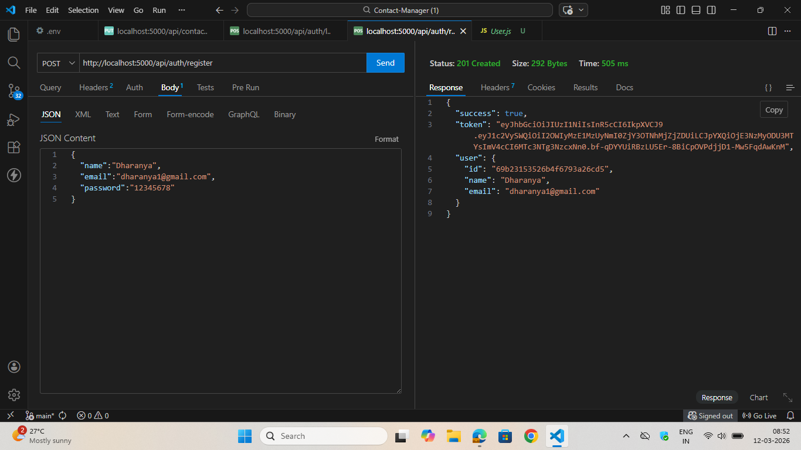

- Login Api

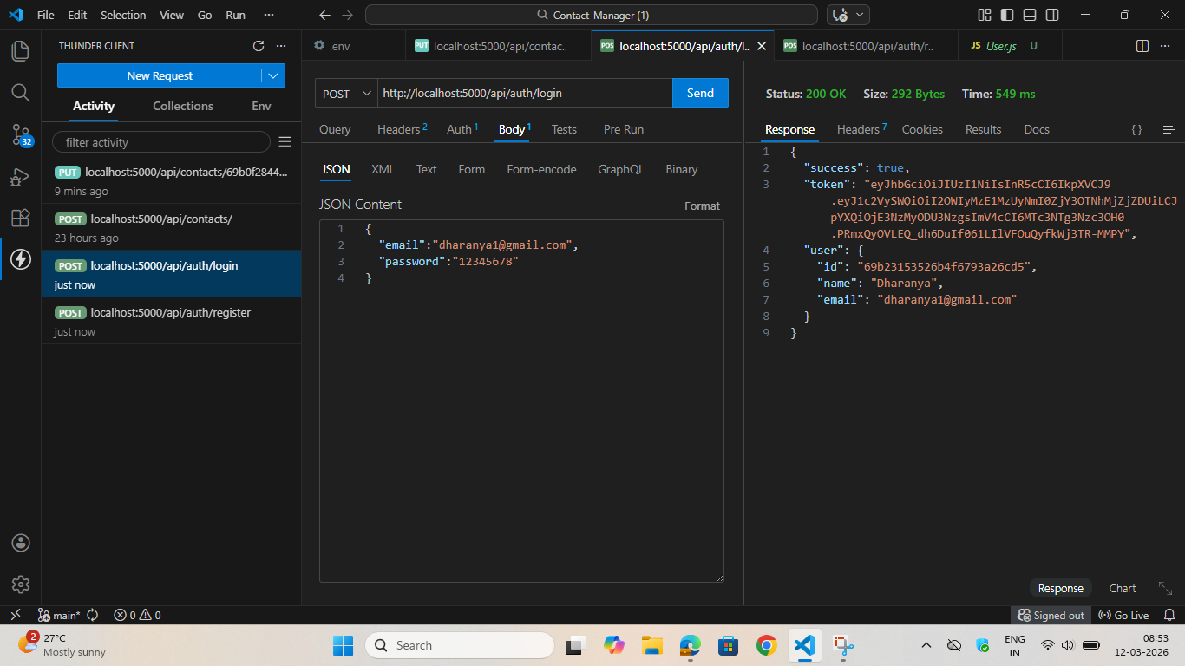

3.Create New Contact

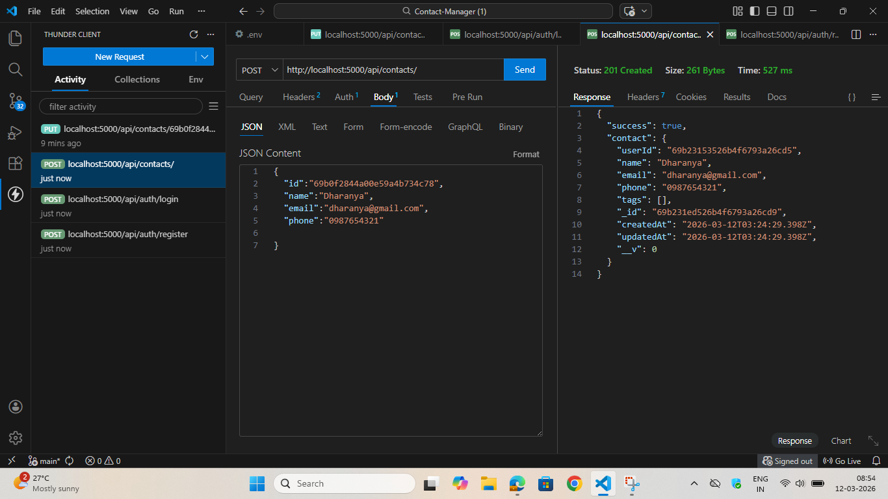

- Update Contact
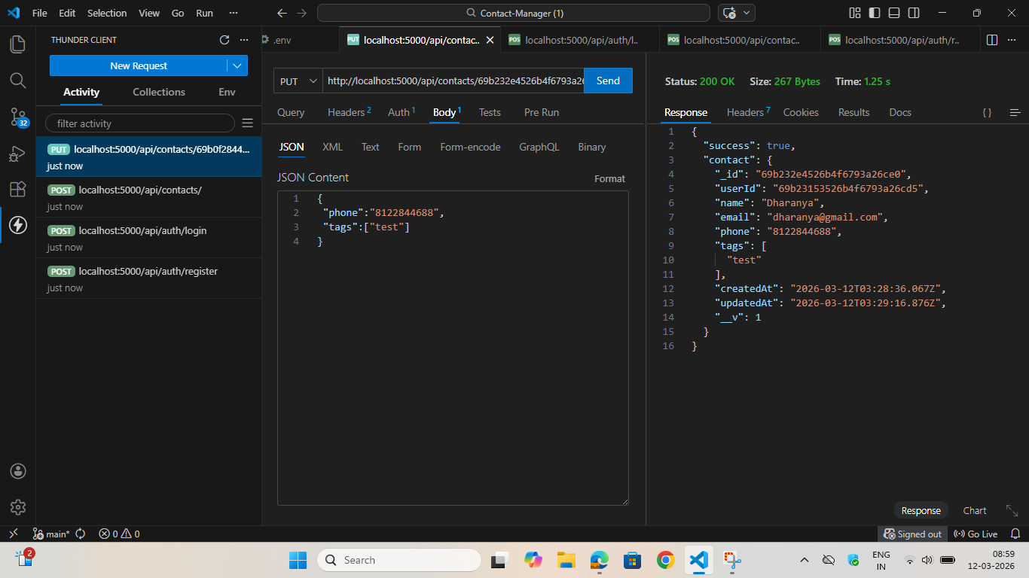

- Delete Contact

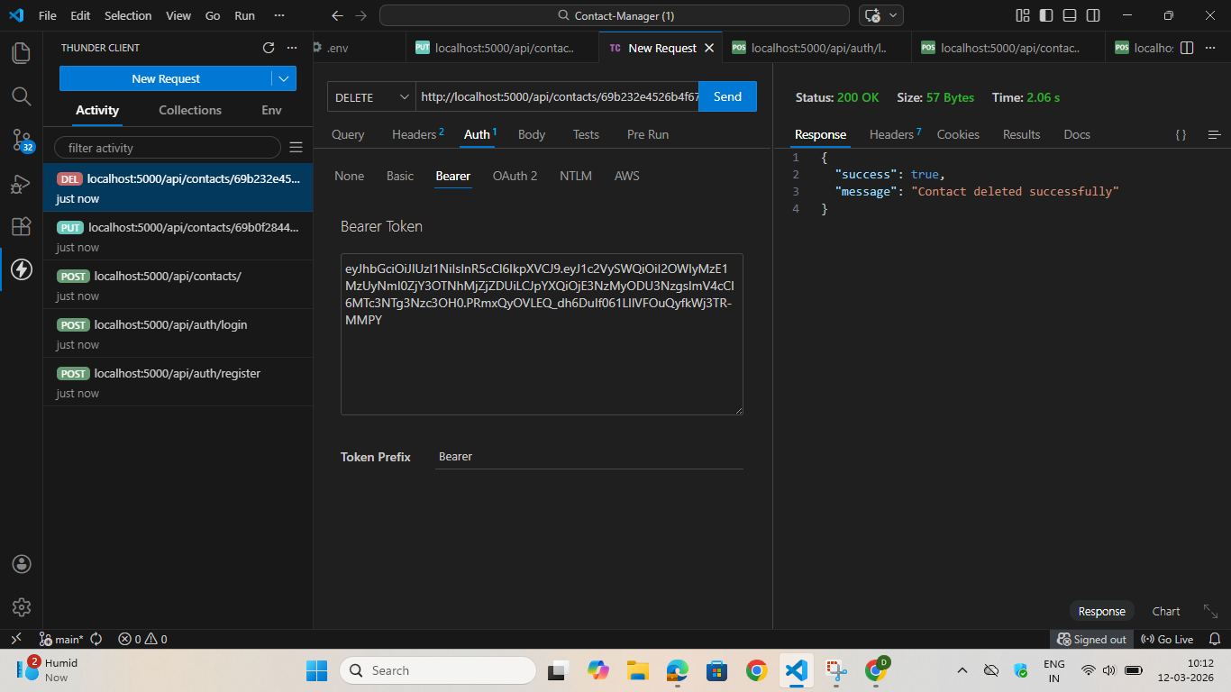

- Search Contact

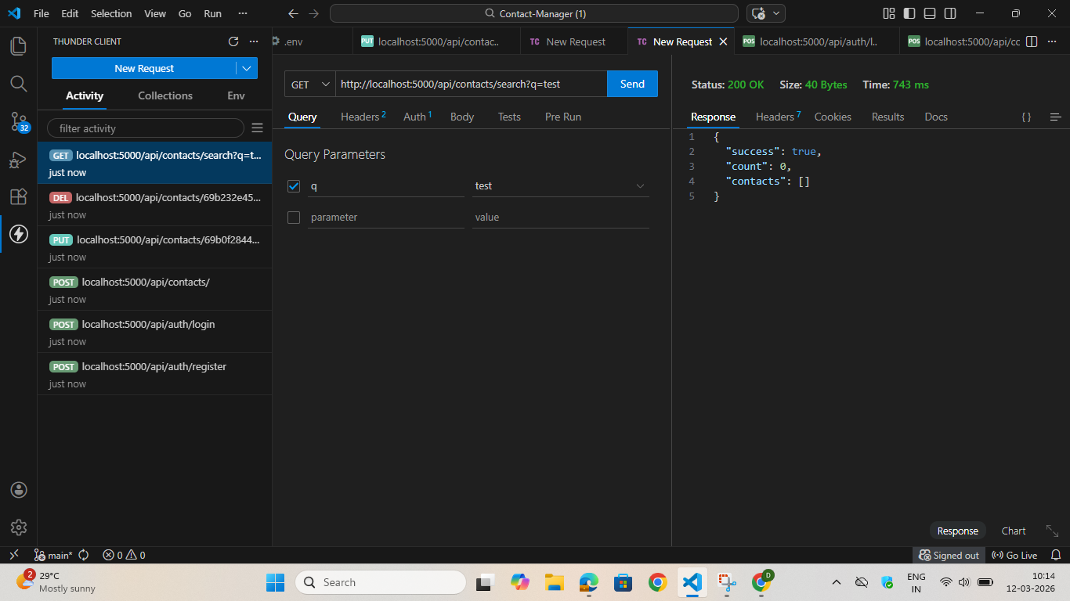

- Get The Current User

